3rd Annual ~ LMYC Detroit River Dinghy Regatta ~ Saturday Oct 8, 2022
Hosted by LaSalle Mariners Yacht Club 2640 Front Rd LaSalle Ontario and Force 5 Fleet 115
Notice of Race
Eligibility: This regatta is open to Force 5 class dinghies and other small sailing dinghies.
Rules: This event will be governed by the ‘rules’ as defined in The Racing Rules of Sailing (RRS) 2021-2024
Course Area: We will be using the Detroit River between the LaSalle shoreline and Fighting Island, and Grassy Island and Turkey Island. Course lengths will be approximately 2 Nm. Course sheets will be available at registration.
Registration and Entry: Will be from 10:30 - 11:00 at the Tiki bar - north of club house. We ask that you sign the attached entry form and submit it at registration. Extra entry forms will be available. There is no entry fee.
Sailing Instructions: SIs will be available at registration.
Skippers Meeting: Will be at 11:00 at the Tiki Bar.
Races: We will sail as many races as possible within the 3 hour limit. There will be at least a 2 minute gap between the last boat finishing and the Warning signal of the next race
First Warning Signal: 12:00
No Race Warning Signal after 3:00pm
Safety equipment: All skippers and crew must wear an approved PFD during the races! A tow line - of at least 15' attached at the bow or 20' attached to the mast of your dinghy - is also required.
Penalties: A boat shall take “One 360 Turn Penalty” - for breaking a rule of Part 2 of the RRS. This changes Rule 44.1
Disclaimer of Liability: Competitors participate in the races entirely at their own risk. See RRS Rule 4, Decision to Race. The organizing authority will not accept any liability for material damage or personal injury, or death sustained in conjunction with or prior to, during, or after the race
<>
Parking: Anyone bringing a boat and/or gear for the regatta is asked to unload your stuff on the grass just NE and west of the clubhouse and park your vehicle down in the parking lots. Vehicles with trailers are to park neatly between the shed and cedar trees in the main parking lot.
Food and Drink: Bottled water will be provided. Other than that, please bring your own beverages and snacks. At registration, we will have an order sheet for pizza - for consumption after racing is done. We will order it after everyone is back in. We will use Capri Pizza on Front Rd. If you wish to order some pizza, you will be asked to pay before we order it. You will pay by the slice.

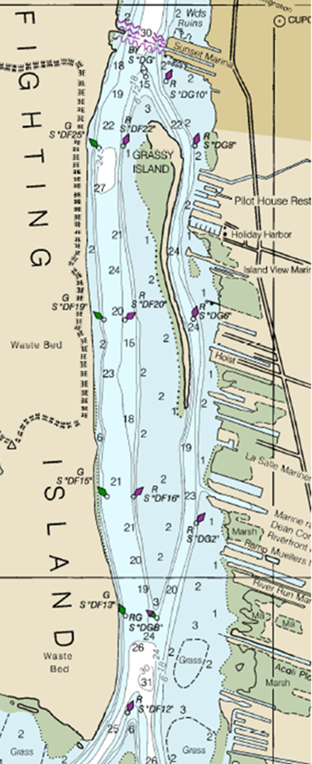

LaSalle Mariners Yacht Club

ENTRY FORM
2022 LMYC Detroit River Dinghy Regatta LaSalle Ontario Sat Oct 8, 2022
SKIPPER (AND CREW) NAME_______________________________________________________________________
BOAT TYPE_____________________________________________________________________________________
HULL COLOUR(S)________________________________________________________________________________
SAIL NUMBER____________________________________________
I agree to be bound by The Racing Rules of Sailing and by all other rules that govern this event

Signed________________________________________________________________________________________

